Welcome
The AcadeMir Charter School Preparatory 1st ever Summer Camp will provide children with supervised activities and field trips that will be new and exciting. Every day, campers will experience nurturing relationships with staff and also develop friendly relationships with peers. In addition, campers will participate in daily activities like hands-on multimedia, athletic development, and creative arts, all while building a sense of teamwork and friendship.
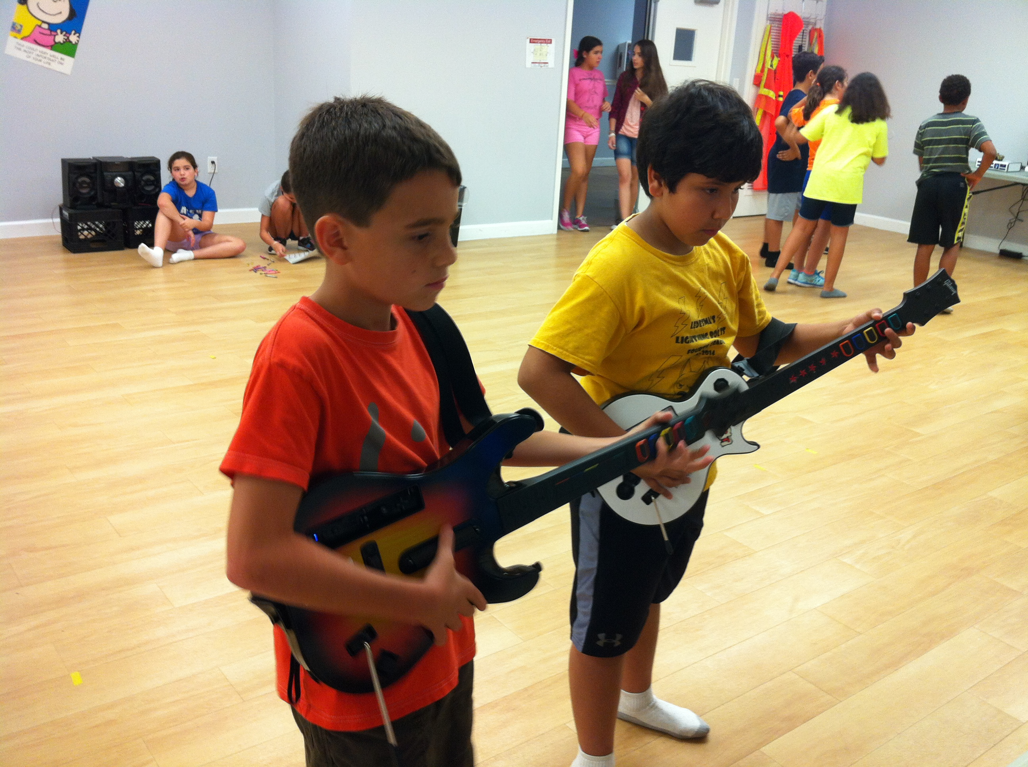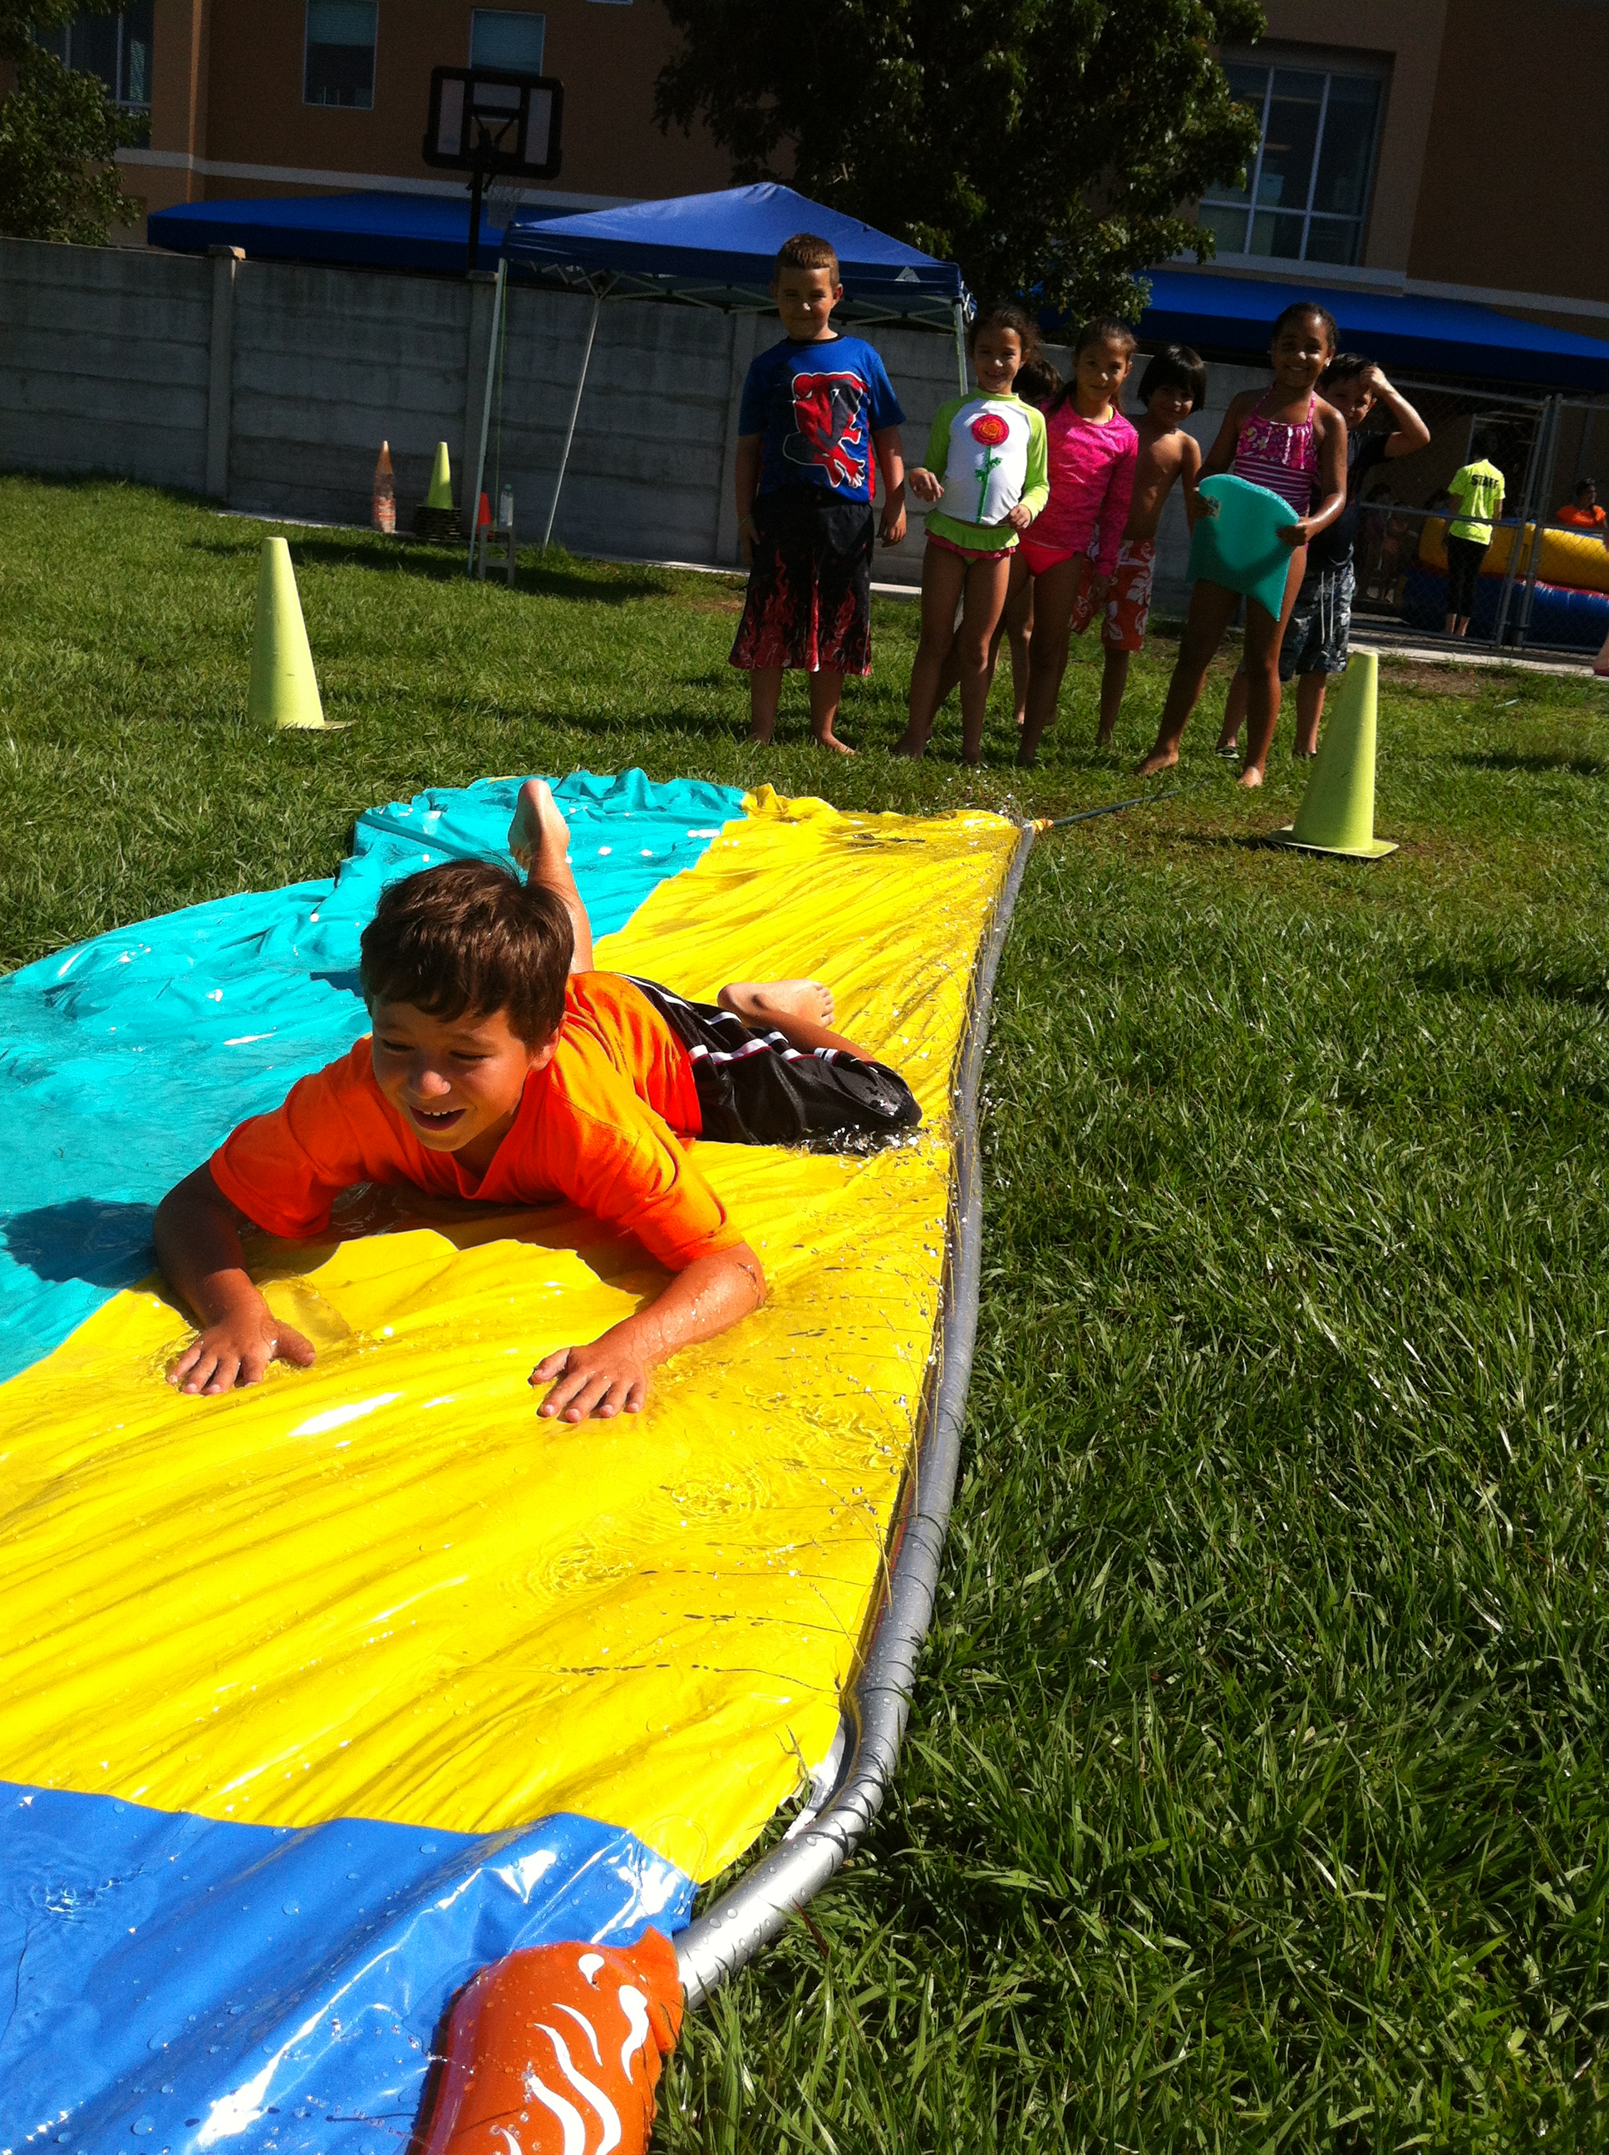
Compare  Summer Camps | Lunch | Weekly  Price
AcadeMir | Free | $135.00
Zoo Miami | $40.00 | $200.00

‘Sample’ Daily Schedule
7:00am-9:00am Free Early Drop Off
9:00am-9:15am Summer Chat
9:15am-10:05am Sport Activity
10:05am-10:55am Fun Room
10:55am-11:25am Lunch Time
11:30am-12:20pm Playground Activity
12:20pm-1:10pm Wheel Room
1:10pm-2:00pm Court Time
2:00pm-2:20pm Snack Time
2:20pm-3:10pm Video Game Arcade
3:10pm-4:00pm Board Games
4:00pm-4:50pm Group Play Outdoors
4:50pm-5:00pm Snack Time
5:00pm-6:00pm Cafeteria Cool Down
Water Slide Tuesdays
FREE
FREE Lunch Program
Healthy Children Catering
Prices
Registration Fee (one time only):
$50 per household; includes 1 t-shirt
(Non-Refundable/Non-transferrable)
‘Weekly’ Price: $135* All inclusive.
*Payment must be received prior to week of camp or a late fee will apply ($25). Includes: Daily lunch and drink, 2 daily snacks, all field trips, bus services, water slide days, dance parties with prizes, on-campus “Fun Days”.
*10% off total price for siblings, Nurses, Police Officers, Military, and Firefighters.
‘Bi-Weekly’ Discount (10% off):
$243 total (save $27 if paid by April 7th)
`Half Summer’ Discount (10% off):
$486 total (save $54 if paid by April 7th)
Summer A: June 12 – July 7
Summer B: July 10-August 4
'Whole Summer’ Discount (15% off):
$918 total (save $162 if paid in full by April 7)
FREE Field Trips
(Wednesdays)
- GameTime
- Gator Park
- Laser Land Adventure
- Dandy Bear
- Movie Theater
- Action Town
- Dave and Buster’s
- Bowling at Strike Miami
**All parent volunteers must be cleared by the main office staff.

Middle School
(5th, 6th, and 7th graders)

- FREE Robotics

Reminders
- Peanut Free School
- All payments are non-refundable and non-transferrable
- Extra Camp Shirts for sale ($10)
- Parents must 'Sign-Out' camper daily
- Camper Dress Code: sneakers, appropriate shorts, and any AcadeMir t-shirt
- Wet Days need: towel, sunscreen, camp shirt, sandals/crocs, bathing suit, and extra clothes in a bag
- Rainy Days: campers will be indoors in small groups and additional educational activities will be available
- Not Allowed: iPods, Pokemon cards, cell phones, toys, and personal video game systems
- Late pick up fee of a $1 a minute after 6:05 pm
- If you miss the bus on field trip days or don’t want to go, there is no supervision at school!
- High School volunteers welcome

AcadeMir
Summer Camp
(Ages 5 - 13 years old)
June 12–August 4
Monday - Friday
Space is Limited
7:00am - 6:00pm
For more information, please contact Coach Williams:
(305) 964-7542 or fax (305) 964-7458
BobbyDeanWilliams02@gmail.com
AcadeMirCharterSchoolPreparatory.com
19185 SW 127th ave, Miami, FL 33177

